|  |
| --- |
| **Petrol Stations Locator** |
| Project Charter |
|  |
| This document carries the project charter for Petrol Station Locator project. It focuses on details such as project timelines, scope, risk, development plan. |
|  |
| **The Fighting Mongooses** |
| **9/30/2012** |
|  |

Contents

General Information 3

Project Objective 3

Assumptions 3

Project Scope 3

Excluded items from the scope 3

Project Milestones 4

Work Breakdown Structure 5

Project Development Methodology 6

Roles and Responsibilities 6

Resources 7

Risks 8

Signatures 9

# General Information

|  |  |  |  |
| --- | --- | --- | --- |
| Project Title: | Petrol Station Locations Data Mash Up | | |
| Brief Project Description: | Display locations of petrol stations on Google maps using datasets from petroleum companies. | | |
| Prepared By: | Peter Monus, Irfan Arif | | |
| Date: | 20 September 2012 | Version: | 1.0 |

# Project Objective

To create a website holding a Google map containing petrol station locations across all of Australia. In addition, the website will provide users with directions to the nearest petrol stations and is able to find those with specific fuel types and services.

# Assumptions

Below are the assumptions undertaken while passing an input to the project plan and scope. Few assumptions are very critical and may have a negative impact as highlighted in bold where as others assumptions can be negotiated.

* Resource availability
* Cost of project will be met regardless of value
* Datasets will continue to be available from all petroleum corporations

# Project Scope

* Locations of petrol stations across Australia, no overseas
* Petrol station will be ones owned by BP, Caltex, Shell and Mobil
* Refined search functions by location, company, and available fuel types
* Ease of access features such as symbolic communication

## Excluded items from the scope

* WCAG2
* Native Mobile app (iOS app, android app)
* Use with other map applications (Bing Maps, Apple Maps)
* Fuel Prices integration on Maps

# Project Milestones

|  |  |  |
| --- | --- | --- |
| **Milestones** | **Deliverables** | **Date** |
| Initiation and Analysis | * Project Charter * Project Plan * Risk Log * Issues Log * Feasibility Study | Week 5-8 |
| Design | * Website design storyboard * Website design wireframe * Code Design | Week 8 |
| Development | * Graphics Design * Collecting Datasets * Cleaning Datasets * Google Maps Integration * Dataset Integration * Refined Search Functions | Wk 9-12 |
| Testing | * Unit Testing * User Acceptance Testing * Bug Fixing | Wk 13 |
| Supporting Documentation | * User Manuals * Code Specifications * Maintenance Documentation Testing Documentation |  |
| Release | * Final release of project | Wk 13 |
| Close | * End of project | Wk 14 |

# Work Breakdown Structure



# Project Development Methodology

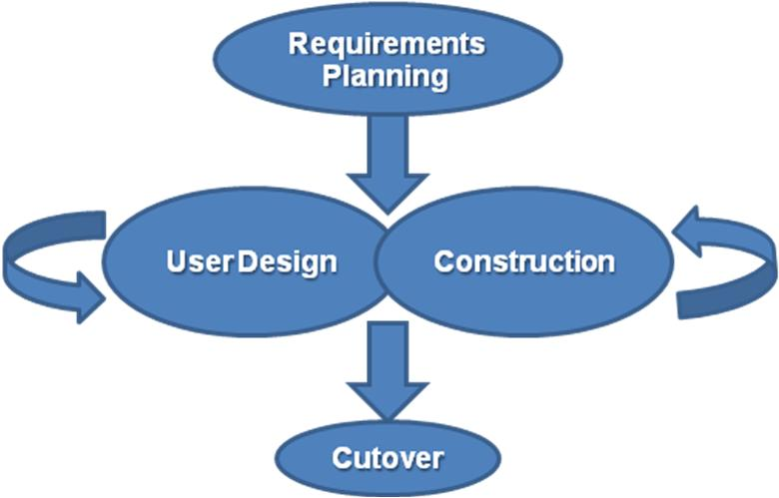

The project will be using a RAD methodology, this allows us to at first gather the requirements for the project at the start with a short analysis and design phase. Development and Design will happen in iterations with changes to the design and new prototypes being added regularly.

# Roles and Responsibilities

|  |  |  |  |
| --- | --- | --- | --- |
| **Sponsor:** Provides overall direction on the project. Responsibilities include: approve the project charter and plan; secure resources for the project; confirm the project’s goals and objectives; keep abreast of major project activities; make decisions on escalated issues; and assist in the resolution of roadblocks. | | | |
| **Name** | | **Email / Phone** | |
| Scott Ashwin & Co. | | Scott.ashwin@canberra.edu.au | |
| **Project Manager:** Leads in the planning and development of the project; manages the project to scope. Responsibilities include: develop the project plan; identify project deliverables; identify risks and develop risk management plan; direct the project resources (team members); scope control and change management; oversee quality assurance of the project management process; maintain all documentation including the project plan; report and forecast project status; resolve conflicts within the project or between cross-functional teams; ensure that the project’s product meets the business objectives; and communicate project status to stakeholders. | | | |
| **Name** | | **Email / Phone** | |
| Irfan Arif | | U3086511@canberra.edu.au | |
|  | |  | |
| **Team Members:** Works toward the deliverables of the project. Responsibilities include: understand the work to be completed; complete research, data gathering, analysis, and documentation as outlined in the project plan; inform the project manager of issues, scope changes, and risk and quality concerns; proactively communicate status; and manage expectations. | | | |
| **Name** | **Role** | | **Email / Phone** |
| Peter Monus | Data Analyst/ Programmer | |  |
| Irfan Arif | Project Manager/ Programmer | | U3086511@canberra.edu.au |
| Liam Davis | Programmer/Tester | |  |
| Riemke Aggio | Graphics Designer/ Tester | |  |
| **Customer:** The person or department requesting the deliverable. Responsibilities include: partner with the sponsor or project manager to create the Project Charter; partner with the project manager to manage the project including the timeline, work plan, testing, resources, training, and documentation of procedures; work with the project team to identify the technical approach to be used and the deliverables to be furnished at the completion of the project; provide a clear definition of the business objective; sign-off on project deliverables; take ownership of the developed process and software. | | | |
| **Name** | | **Email / Phone** | |
| Scott Ashwin & Co. | | Scott.ashwin@canberra.edu.au | |
| **Subject Matter Expert:** Provides expertise on a specific subject. Responsibilities include: maintain up-to-date experience and knowledge on the subject matter; and provide advice on what is critical to the performance of a project task and what is nice-to-know. | | | |
| **Name** | | **Email / Phone** | |
| Scott Ashwin | | Scott.ashwin@canberra.edu.au | |
| Ranjhita | |  | |

# Resources

|  |  |
| --- | --- |
| Resource | Constraints |
| Project Budget | $10,000 |
| Hours | 400 |
| Days | 28 |
| Development Team | 1 Project Manager  1 Graphics Designer  1 Developer  1 Tester |

# Risks

|  |  |  |
| --- | --- | --- |
| Risk | Impacts | Mitigation Strategy |
| Small Team | A cut down of a member can have a drastic effect on a project | * Enough buffer hours * Slack hours * Work replacements |
| 3rd Party API | Relying heavily on external API for building maps. | Secondary API consideration as worst case |
| Internet broken down | No offline browsing of maps in possible so development may come to a complete halt. | * Use some other Internet source like mobile as a router * 3g EVO connection. |
| Scope changes | Project deadline may not meet, Budget may vary | * Enough buffer hours * A new sprint will be created for additional scope |
| 3rd Party Maps usage restrictions exceeded | Maps would not be accessed. | * Use of a new key |
| Computer Broken | May cause a project tasks not finished by time | * Use of university Labs |
| Data Lost | Waste of work on project key items | * Regular backups * Use of an online source safe tool to publish data on the cloud. |
| Schedule Risks | Project deadline may not accomplish | * Have sufficient buffer hours and monitoring those efficiently |
| Budget risk | Project may come to halt in case of no budget | * Define budget correctly * Study various projects of similar nature and then compare the cost |

# Signatures

|  |  |  |
| --- | --- | --- |
| **Customer:** |  |  |
| **Name** | **Signature** | **Date** |
| Scott Ashwin | Scott Ashwin | 04-10-2012 |
|  |  |  |
| **Project Sponsors:** |  |  |
| **Name** | **Signature** | **Date** |
| Scott Ashwin | Scott Ashwin | 04-10-2012 |
|  |  |  |
| **Project Manager:** |  |  |
| **Name** | **Signature** | **Date** |
| **Muhammad Irfan Arif** | **Muhammad Irfan Arif** | **02-10-2012** |
|  |  |  |